**DAILY ONLINE ACTIVITIES SUMMARY**

|  |  |  |  |  |  |  |  |
| --- | --- | --- | --- | --- | --- | --- | --- |
| **Date:** | **22-05-2020** | | | **Name:** | | **B.A.SOHANKUMAR** | |
| **Sem & Sec** | **4TH SEM A** | | | **USN:** | | **4AL18CS013** | |
| **Online Test Summary** | | | | | | | |
| **Subject** | | **OPERATING SYSTEM** | | | | | |
| **Max. Marks** | | **30** | | | **Score** | **19** | |
| **Certification Course Summary** | | | | | | | |
| **Course** | **CLOUD FOUNDATIONS** | | | | | | |
| **Certificate Provider** | | | **GREAT LEARNING ACADEMY** | | **Duration** | | **4.5 HOURS** |
| **Coding Challenges** | | | | | | | |
| **Problem Statement:1:Write a C or Java program to implement round robin type of process scheduling.**  **Problem Statement:2: Write a C program to implement a various operations on singly linked list Stack.** | | | | | | | |
| **Status:Executed** | | | | | | | |
| **Uploaded the report in Github** | | | | | **YES** | | |
| **If yes Repository name** | | | | | **LOCKDOWN CODING** | | |
| **Uploaded the report in slack** | | | | | **YES** | | |

**ONLINE TEST DETAILS:**

The online test was from module 1 which was 30 MCQ questions. The time duration of online test was 40 minutes from 9.15am to 9.55am.The score of the online test is 19/30.

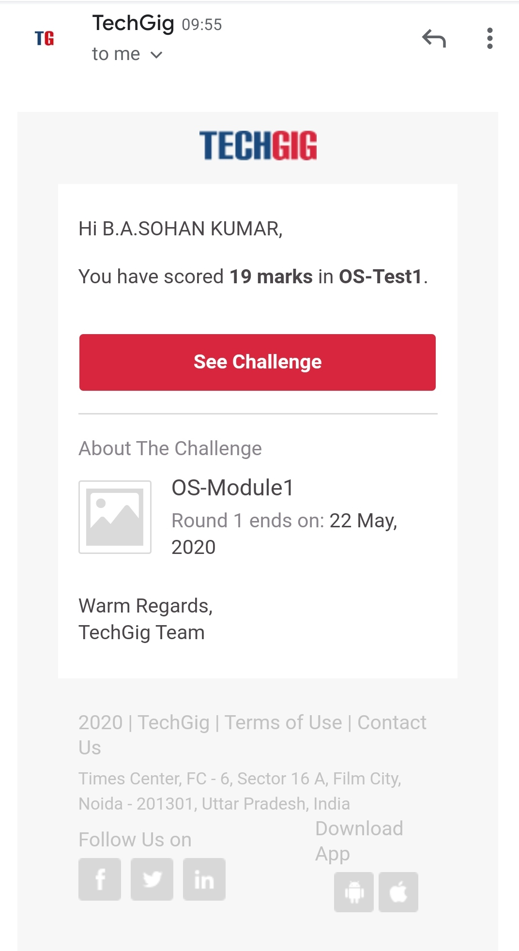

**CERTIFICATION COURSE DETAILS:**

Course Name:CLOUD FOUNDATIONS

Finished with cloud foundation certification course.It contains 11 modules and 1 assessment.Learnt about Business Concerns, Classical Enterprise, Why Cloud & Evolution of Cloud,Service Models, Abstraction Levels, SPIDERS, Cloud Attributes, Managed Services & Deployment Models, Pricing & Scaling Models, Introduction to Virtualization,Data Velocity & Distributed Computing,Apps for Cloud & Security Model, Automation, Abstraction, Provisioning, Allied Tech.

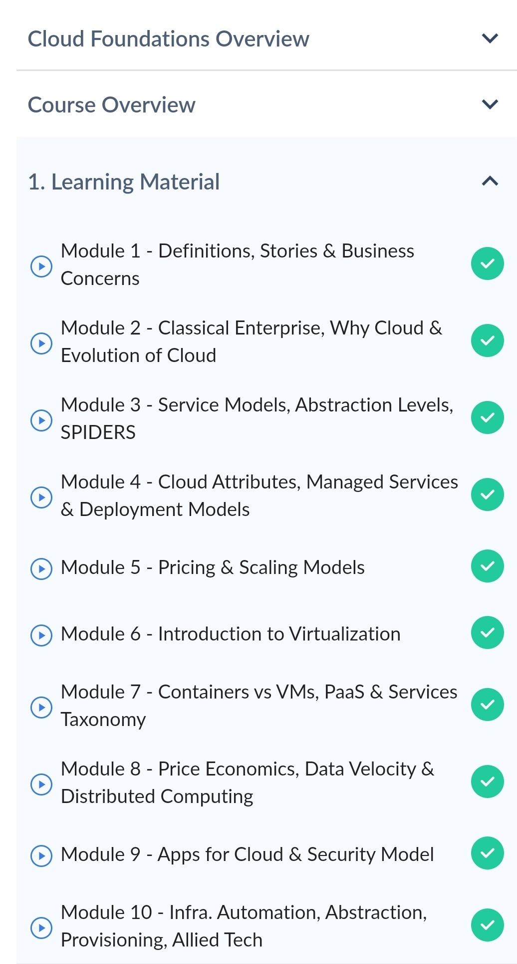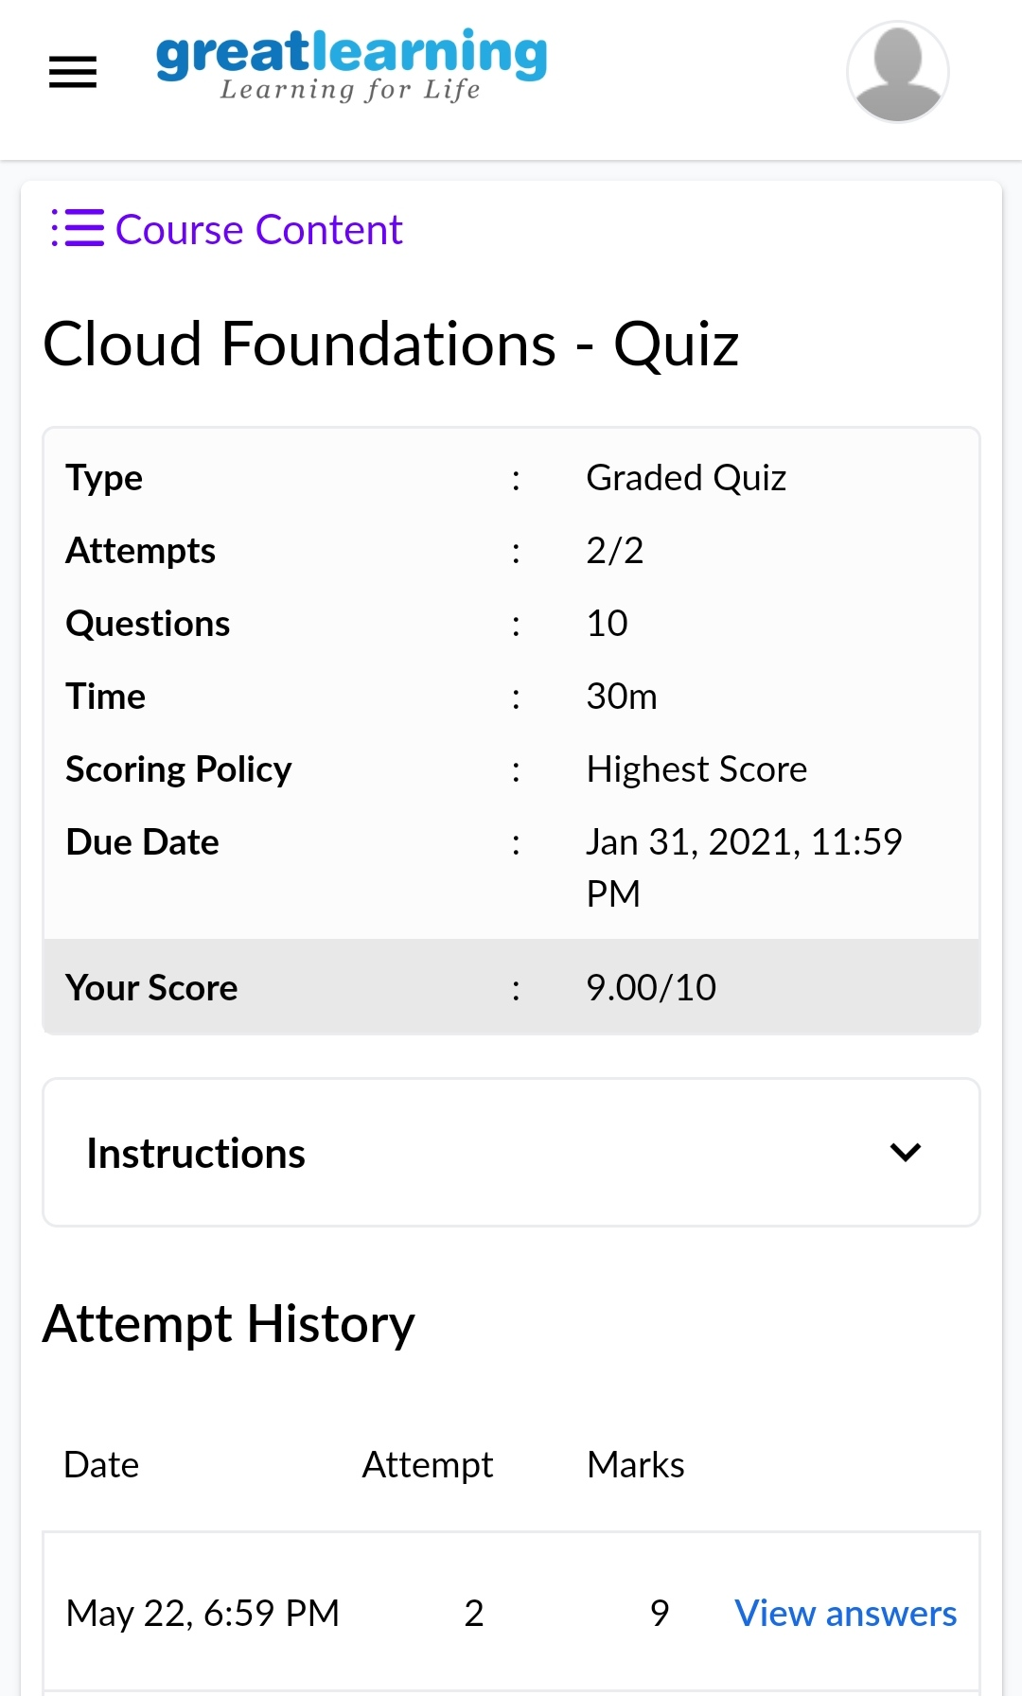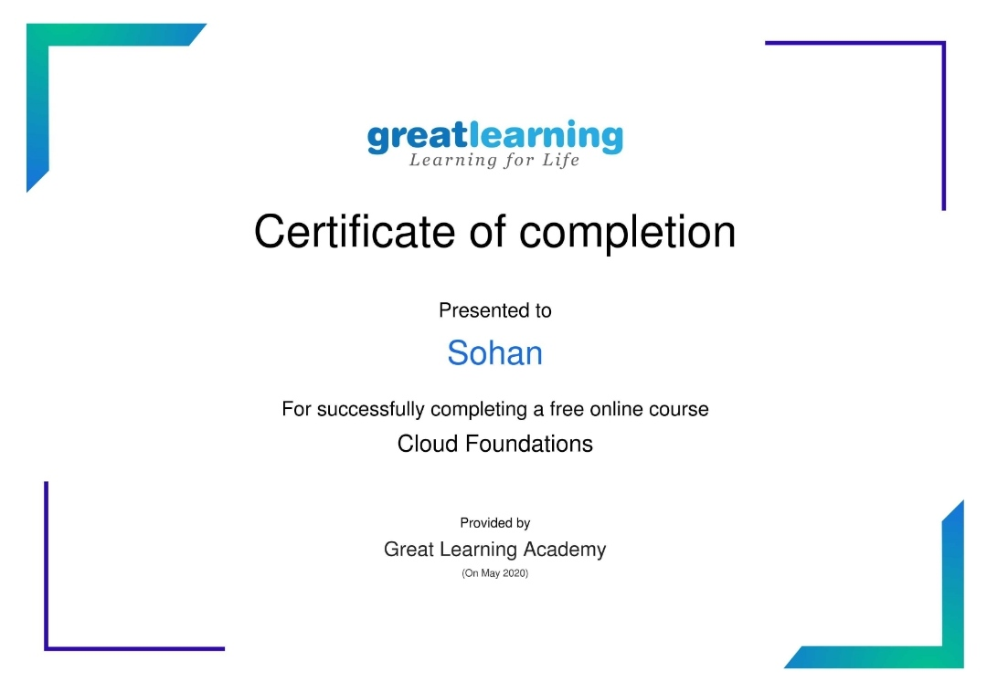

The above certificate is issued by GREAT LEARNING ACADEMY for the completion of CLOUD FOUNDATION online certification course.

**CODING CHALLENGE DETAILS:**

1.C program to implement round robin type of process scheduling.

Input: Process with burst time, arrival time and specify the time quantum

Output: Processes scheduled based on the round robin type of scheduling, with its average waiting time.

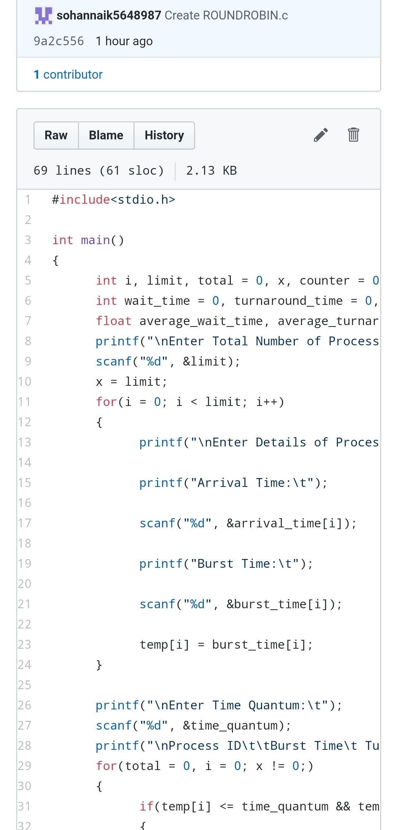

2.C program to implement various operations on singly linked list stack.

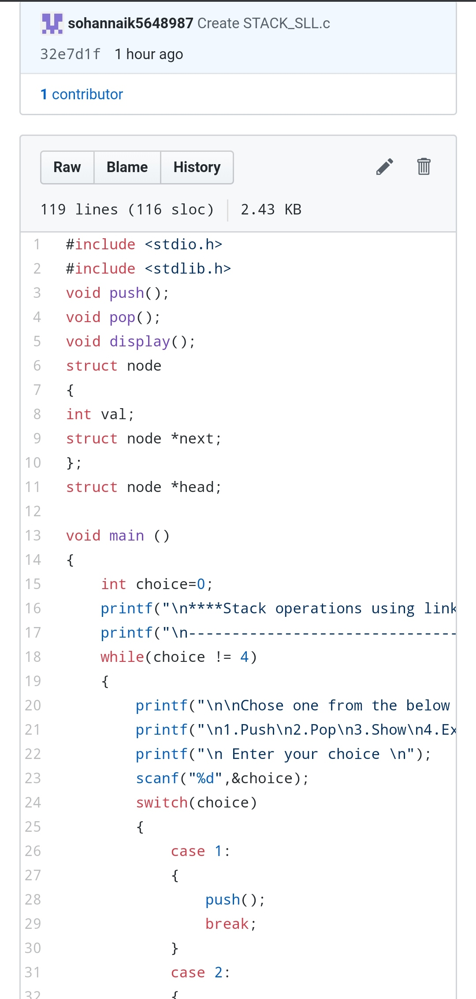

REPOSITORY LINK:https://github.com/sohannaik5648987/lockdown-coding